**Group B**

**Yayan Lin**

**Jingjing Yang**

**Ziqing Zhou**

**Cong Zong**

**Team Github link –** [**https://github.com/ZiqingZhou694/CSC4330ProjectGroupB**](https://github.com/ZiqingZhou694/CSC4330ProjectGroupB)

Introduction:

* Our Goal is to build a front-end of our Tutor website using web development technologies such as HTML, CSS, JavaScript, etc. The unique aspect of our project is for students to use our webpage to schedule an appointment with the tutor so they can have they work complete. In additionally, they system utilizes Java and SQL to handle server-side processing and database management.



Main technology used: HTML, CSS, JavaScript, SQL, Vue.js

* HTML is a markup language used for structuring the content of webpages. It uses a set of tags and attributes to define the structure and content of the webpage. We use it to make our website more distinctive.
* CSS is a stylesheet language used for styling the content and layout of webpages. It provides a set of rules and properties that can be applied to HTML elements to change their appearance, such as colors, fonts, sizes, spacing, borders, and backgrounds. CSS also allows for creating responsive designs that can adapt to different screen sizes and devices. We use this language to set up our images and a series of designs so that our website can be displayed on screens of different sizes.
* JavaScript is a programming language used for adding interactivity and dynamic behavior to webpages. It runs in the client-side browser environment and can be used to respond to user interactions, update the content of the webpage, and interact with external APIs and services.
* Vue.js is a JavaScript framework used for building user interfaces and web applications. It provides a set of tools and libraries for building complex web applications that can handle data, events, and dynamic updates efficiently. Vue.js uses a component-based architecture that allows for creating reusable and modular components, making it easier to maintain and scale large applications. Vue.js also provides features such as reactive data binding, routing, and state management that make it easier to build complex web applications.
  + We use a mixture of JavaScript and Vue.js to run our website templates.
* SQL is a language used for managing and manipulating data in relational databases. It provides a set of commands and syntax for creating, updating, and querying databases. We intended to use it in the backend of web applications to store and retrieve data from databases.

Main aspects of our project design:

* Front-End:
  + Front-end of the website shows the user interface that allows tutors and students to interact on our webpage.
* Back-End:
  + Back-end of the website shows how we handles the server-side functionality.
* Database:
  + Database stores all the data related to the website. Such as user profile, section, plan, and tutor information.

Member’s Role:

* Yayan Lin
  + Front-end, HTML, CSS
* Ziqing Zhou
  + Front-end , Back-end Programmer
* JingJing Yang
  + HTML, Back-end Programmer
* Cong Zang
  + SQL database and Java Programmer

**Functionalities of our project**:

* Home Page: The central feature of the homepage is a large, interactive calendar that displays upcoming appointments for both students and tutors. This helps users stay organized and ensures they do not miss any scheduled sessions. Next to the calendar, a dynamic user population chart is presented, offering a real-time snapshot of the community. The chart visually represents the distribution of students, tutors, and administrators within the app.

* **Login for student, tutor, administrators:** The login system retrieves the username and password information from three separate databases for students, tutors, and administrators, ensuring that each user group has distinct access levels and privileges within the app. The authentication process verifies the entered credentials against the respective database, allowing users to securely access their account and the app's features. Upon successful login, users will be directed to the homepage.

* **Profile**: The profile page displays the user's username, last name, first name, email address, and a content section where users can add additional information about themselves, such as their academic interests or preferred tutoring subjects. Users can edit their personal information directly on the profile page, ensuring that their account details are always up to date. Fields for last name, first name, email address, and content can be edited by simply clicking on them and entering the new information. However, to maintain account security and consistency, the username field is non-editable and remains constant. After updating any personal information, users can save their changes by clicking on a designated save button, which ensures that the updated details are reflected across the app.

* **Administrators:** Have complete access to the system, including a System (Main Menu) Page to manage users, roles, permissions, and more.
  + **Graphical user interface, application, website

    Description automatically generatedUser Page:** The user page is a section of the system that is used for managing user accounts. Administrators have access to this page and can perform various actions such as adding, editing, and deleting user accounts. Additionally, administrators can import and export user data using an Excel file. This functionality allows for efficient management of user accounts and easy transfer of data between systems.

* + **Role Page :** The Role page is used for editing or adding roles to identify different types of user accounts. This allows for the organization of users into different roles and makes it easier to authenticate user accounts and assign permissions.

* + **Permission Page:** Manage permissions for all pages, organizing authentication for each page. There are three types of permissions: menu pages, main menus, and button pages.

* + - Main Menus refers to the menu that is used to group multiple pages together.

* + - Menu Page refers to web pages or content that can be accessed by the user.

* + - Page Button refer to the buttons and component in the web page.

* **Availability Page (Administrators)**: designed to grant administrators the ability to manage and oversee appointments across the platform. This page provides a comprehensive view of all scheduled appointments, displaying important information such as tutor name, date, start time, end time, subject, tutor ID, number of participants, and the meeting link. Administrators have the power to edit any appointment details directly from this page. By clicking on the desired field, they can modify the tutor’s name, date, start time, end time, subject, tutor ID, or number of participants as needed. Additionally, administrators have the option to delete appointments when necessary. A delete button is available next to each appointment entry, allowing administrators to remove the appointment from the system and inform the relevant users about the cancellation.

* **Availability Page (Students):** This page offers a clear overview of all available appointments, with a search bar for filtering results by subject or tutor name. Students can browse through the list of tutors and their available time slots, allowing them to find the most suitable tutor for their needs. Each entry in the list contains essential information about the tutor, such as their name, subject, and available time slots. Two buttons are available next to each tutor’s entry: a "View" button and a "Schedule" button. The "View" button allows students to access more detailed information about the tutor, including their profile, qualifications, and reviews from other students. The "Schedule" button enables students to book an appointment with the selected tutor at a specified available time. Upon clicking this button, students will be guided through the appointment booking process, confirming their selected time slot, and providing any additional information necessary for the session.

* **Availability Page (Tutor):** designed to provide tutors with an organized view of their scheduled appointments. The page displays a list of all the appointments they have made, along with essential details such as subject, time slot, and tutor ID. Two buttons are available next to each appointment entry: "Edit" and "Delete". The "Edit" button allows tutors to modify the details of their existing appointments, such as the date, time, and subject. By clicking on this button, tutors will be directed to an edit page where they can make the necessary adjustments to the appointment information. The "Delete" button enables tutors to remove an appointment from the system.

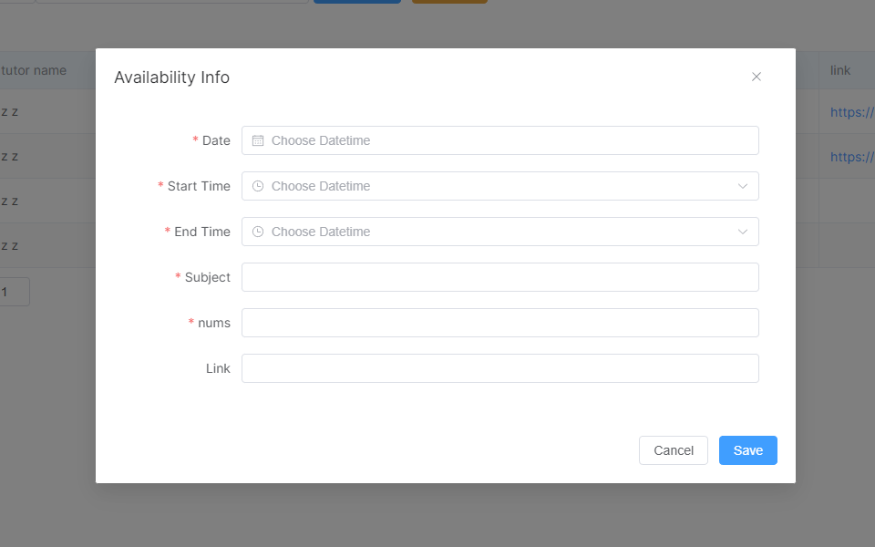

* **Appointment Page (Administrators):** Designed for managing and overseeing appointment requests. This page displays pending appointment requests and their details, such as student name, tutor name, subject, and requested time slot. Administrators can view the status of each appointment request, such as pending, accepted, or declined, to keep track of the overall appointment management process. Administrators have three action buttons available for each appointment request: "Rating," "Accept," and "Decline." Rating: Administrators can view and manage ratings and reviews for tutors. Accept: Administrators can approve appointment requests, notifying both the tutor and student. Decline: Administrators can reject appointment requests, notifying the student to reschedule or find an alternative tutor.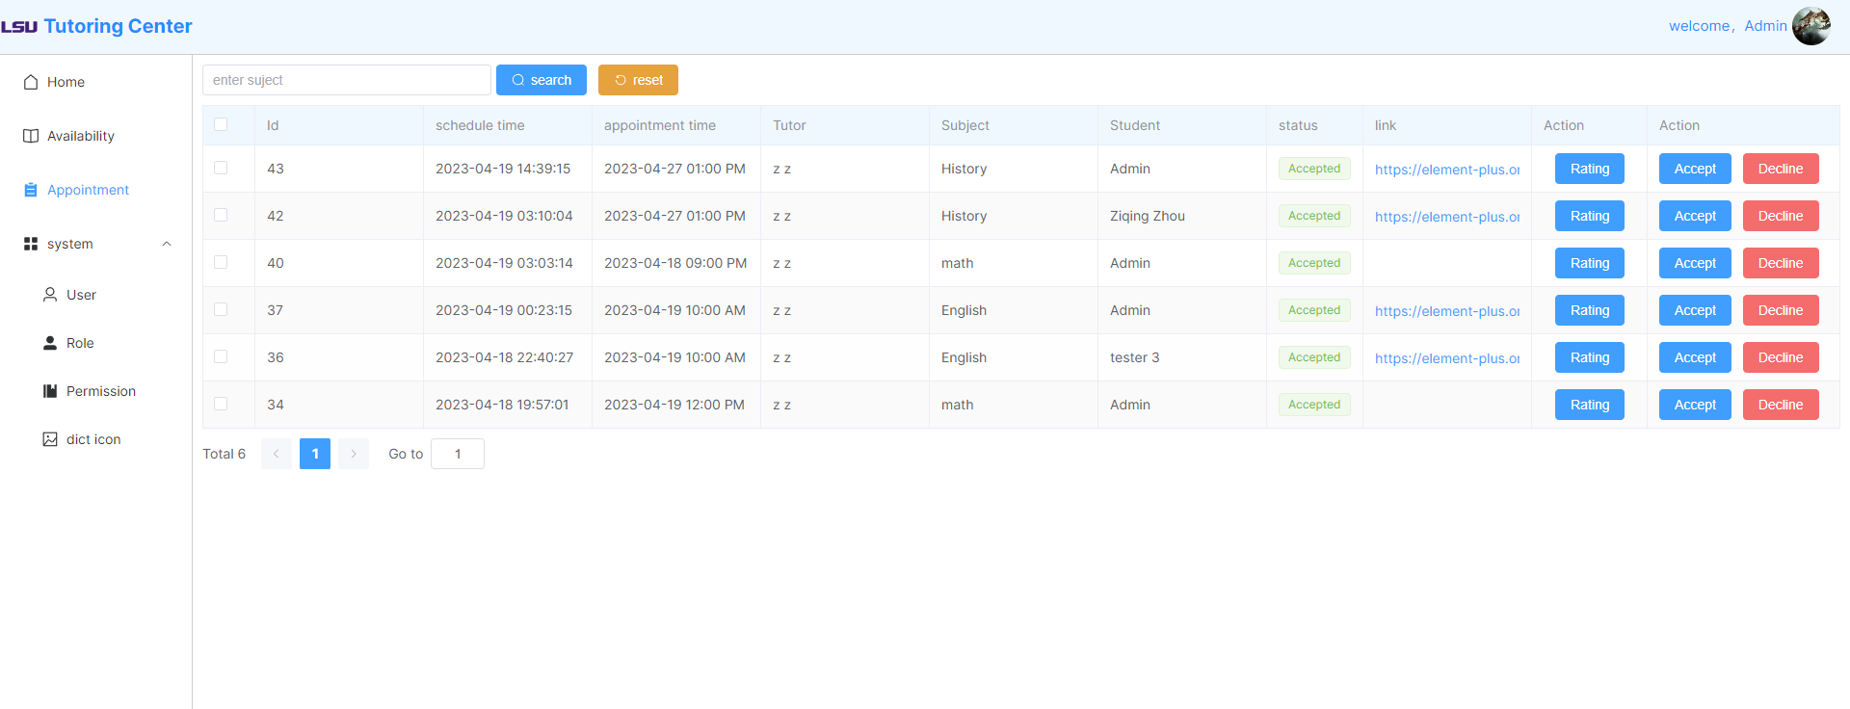
* **Appointment Page (Student):** Designed to help students keep track of their requested appointments and their status. This page displays a list of all appointment requests made by the student, along with important details such as tutor name, subject, requested time slot, and appointment status such as accepted or declined. The "Rating" button allows students to rate their tutors after completing an appointment. This feature helps provide valuable feedback to tutors and assists other students in making informed decisions when selecting a tutor.

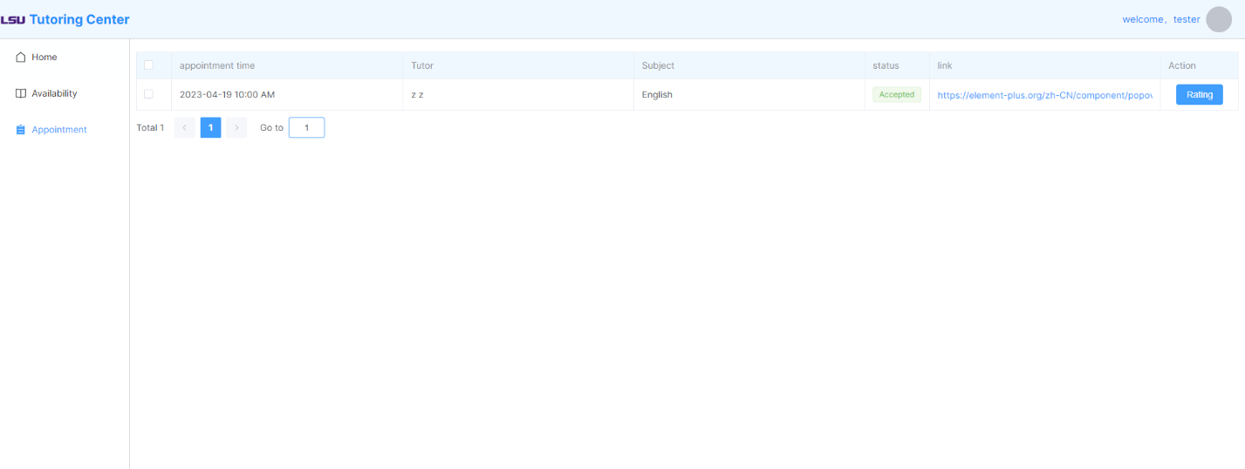

* **Appointment Page (Tutor):** Designed to help tutors manage their appointments and keep track of their status. This page displays a list of all appointments that the tutor has made, along with important details such as student name, subject, requested time slot, and appointment status. The "Accept" button allows tutors to approve an appointment request, confirming the scheduled session with the student. The "Decline" button enables tutors to reject an appointment request, notifying the student to reschedule or find an alternative tutor.

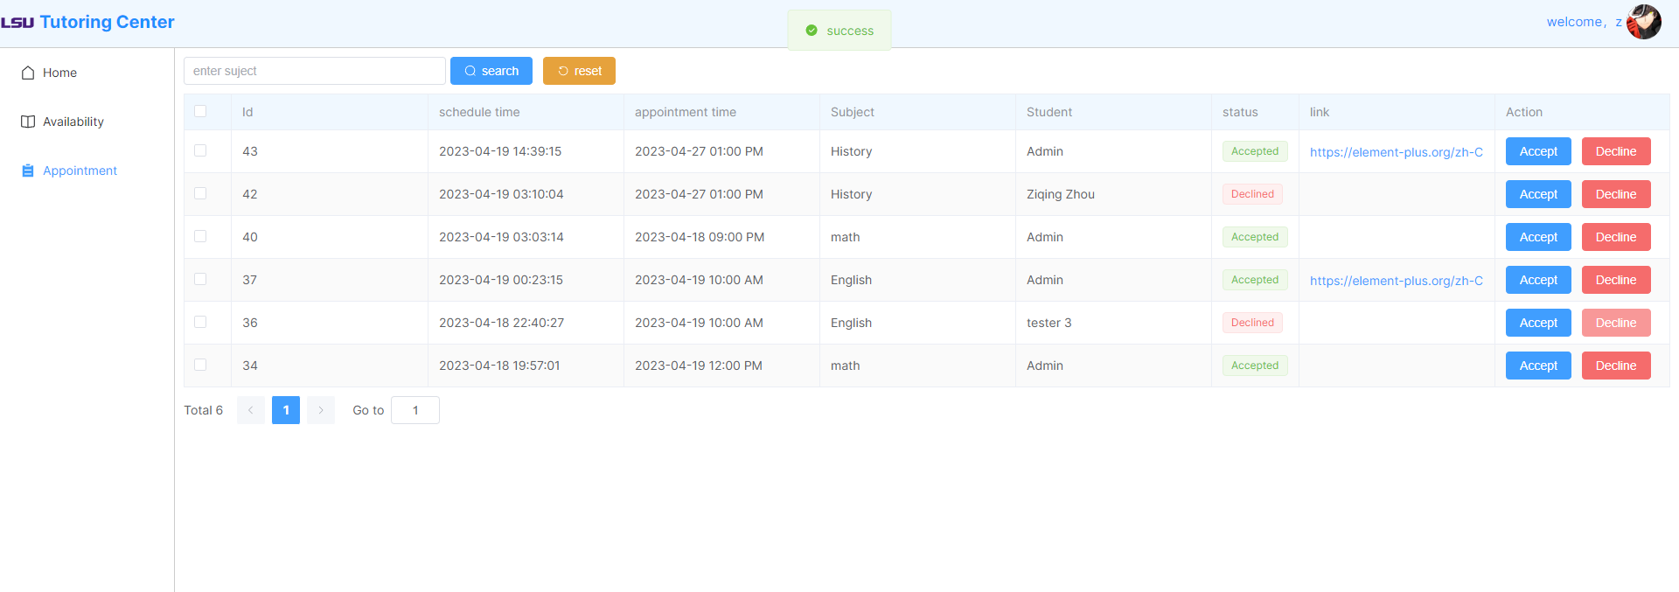

* **Comment and Tutor Information:** Student able to view tutor information and the comments about the tutor.

* **Rating:** Students can rate and comment after their appointment has been accepted.

* **Database:** The tutor app utilizes several databases to manage and store various types of data to ensure seamless functionality and user experience. The following databases are used within the app:



